**Go Full Stack with Spring Boot and React**

**Table of Contents:**

* 1. Introduction

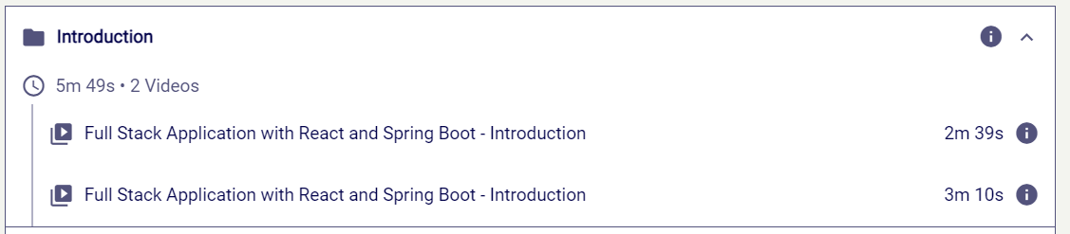

Fig 1.1 : Content of Introduction

* 1. Getting Started with React - Basics with Components

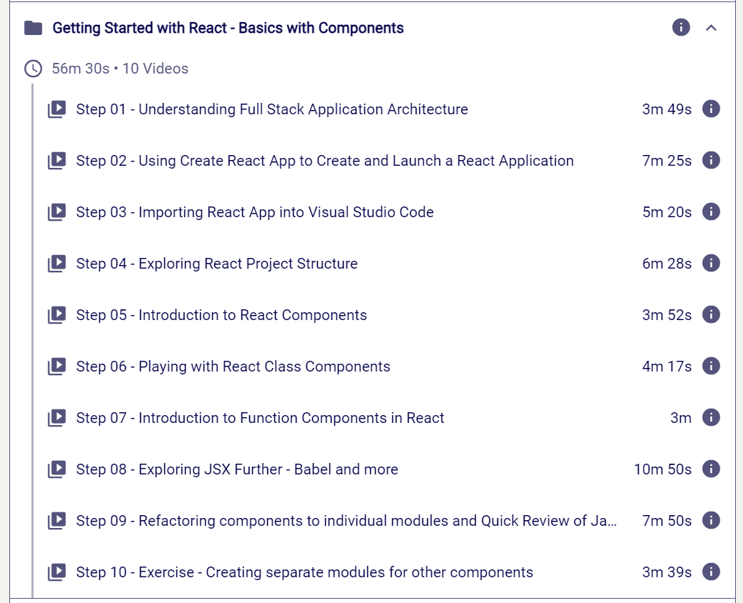

Fig 1.2 : Content of Basics of React

* 1. Next Steps with React - Building Counter Application

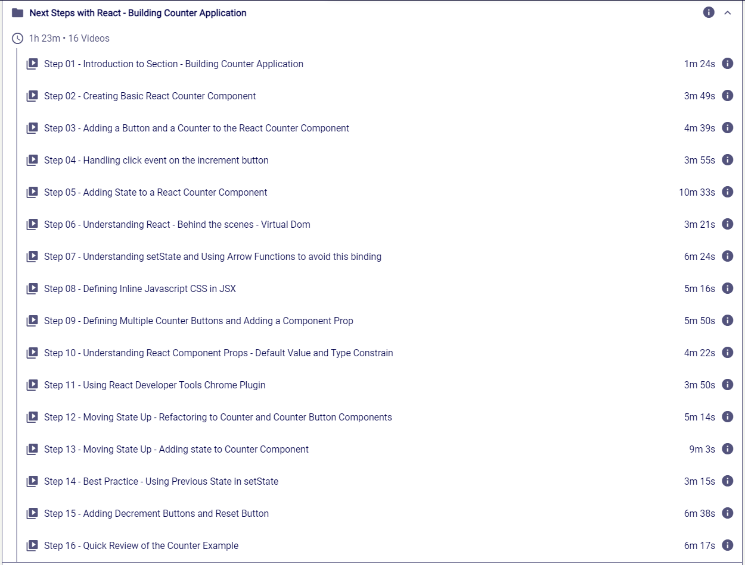

Fig 1.3 : Content of Building Counter Application

* 1. Combining Spring Boot and React to Build Full Stack Todo Management Application

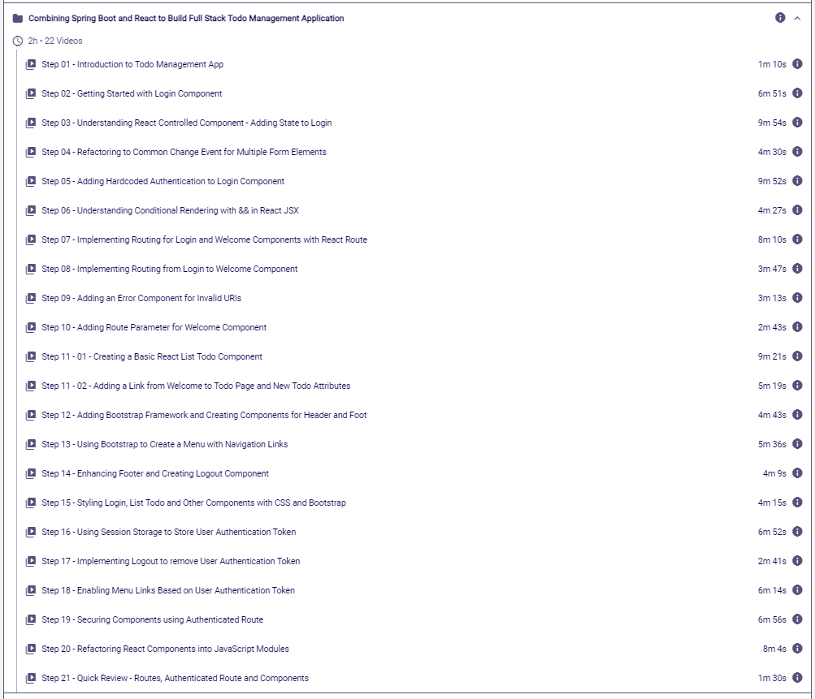

Fig 1.4 : Combining Spring Boot and React

1.5 Getting Started with Spring Boot REST API Services

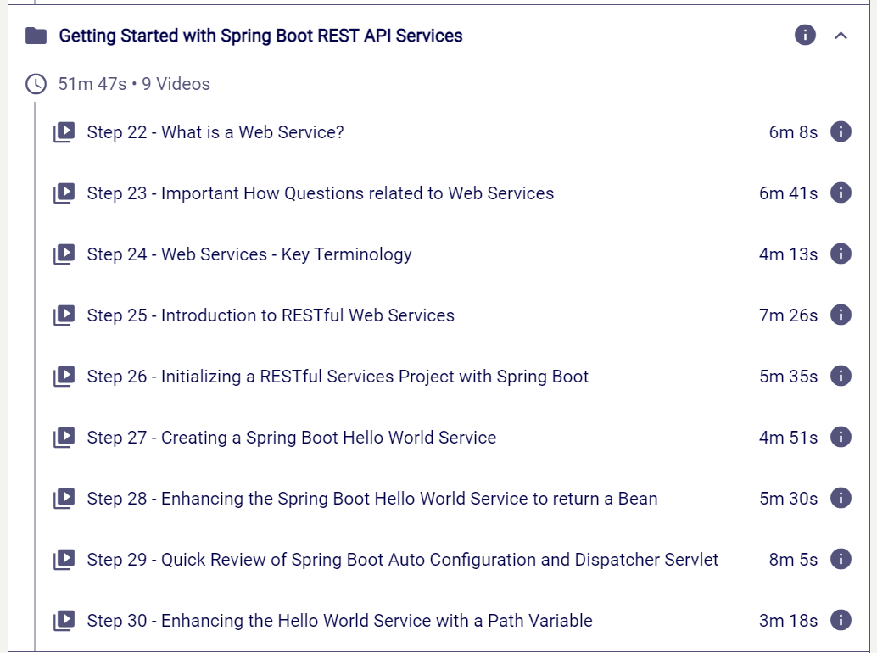

Fig 1.5 : Content of Spring Boot REST API Services

1.6 Connecting Spring Boot REST API with React Frontend

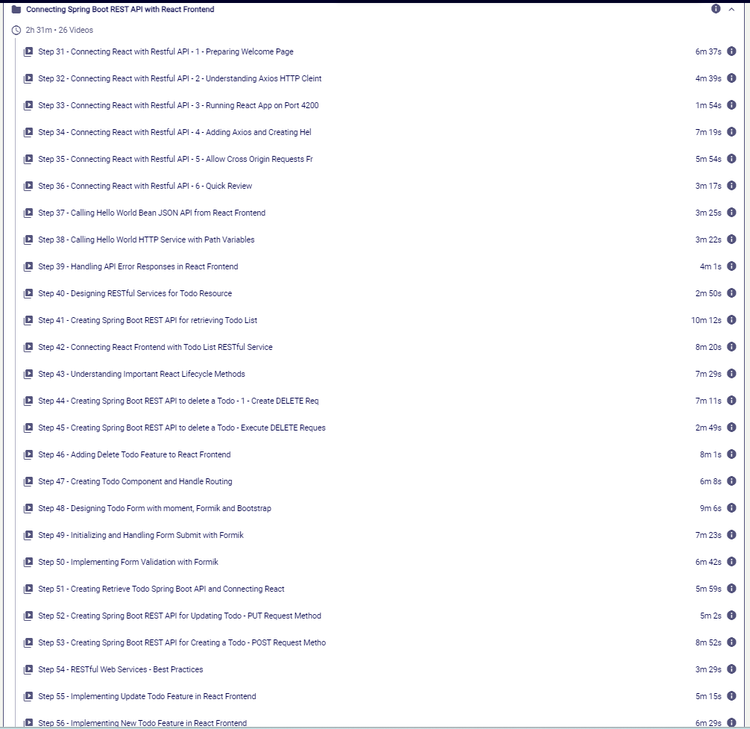

Fig 1.6 : Content of Connecting Spring Boot REST API with React

1.7 Getting Started with Spring Security and Basic Auth

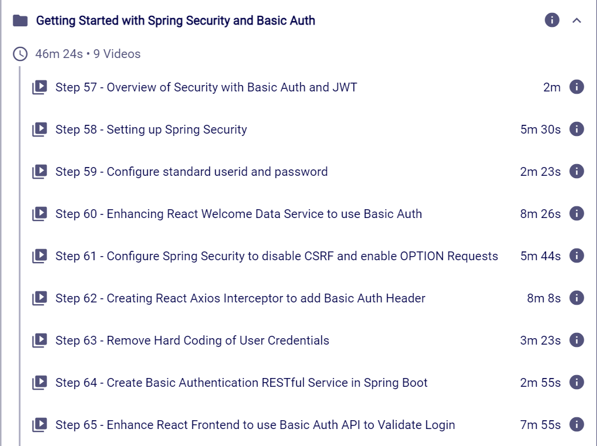

Fig 1.7 : Content of Spring Security

1.8 Getting Started with JWT

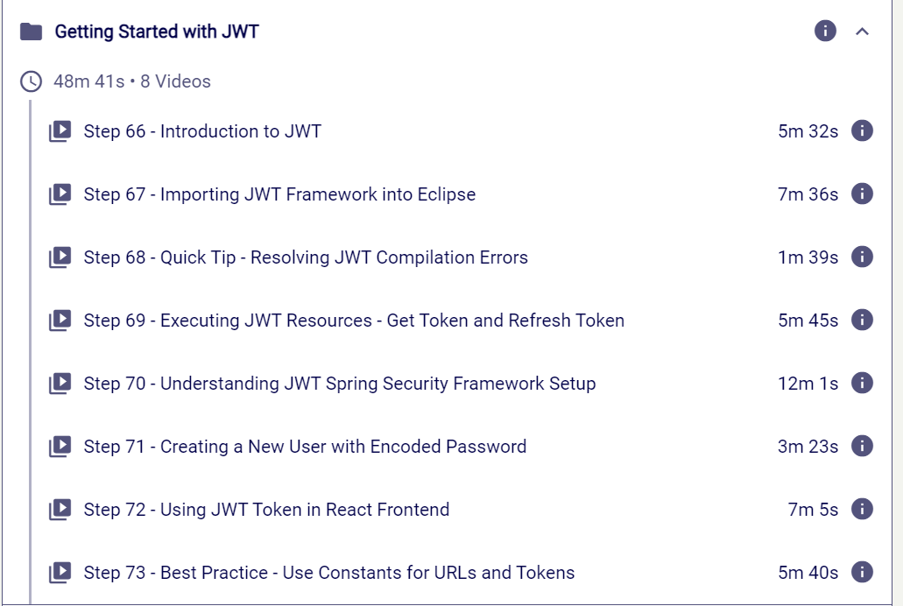

Fig 1.1 : Content of JWT

1.9 Integrating with the Backend using JPA and Hibernate

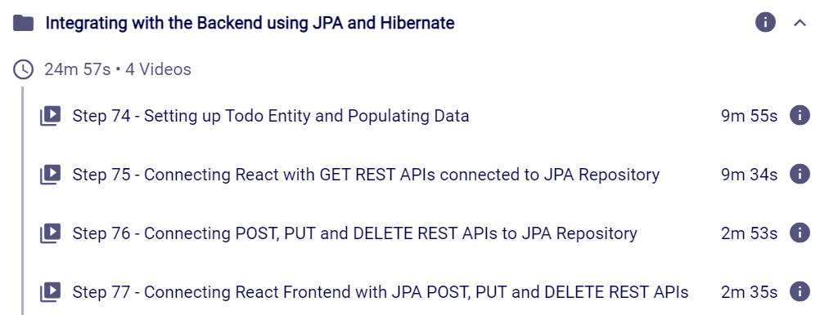

Fig 1.1 : Content of Backend using JPA and Hibernate

1.10 Appendix - Spring Boot in 10 Steps

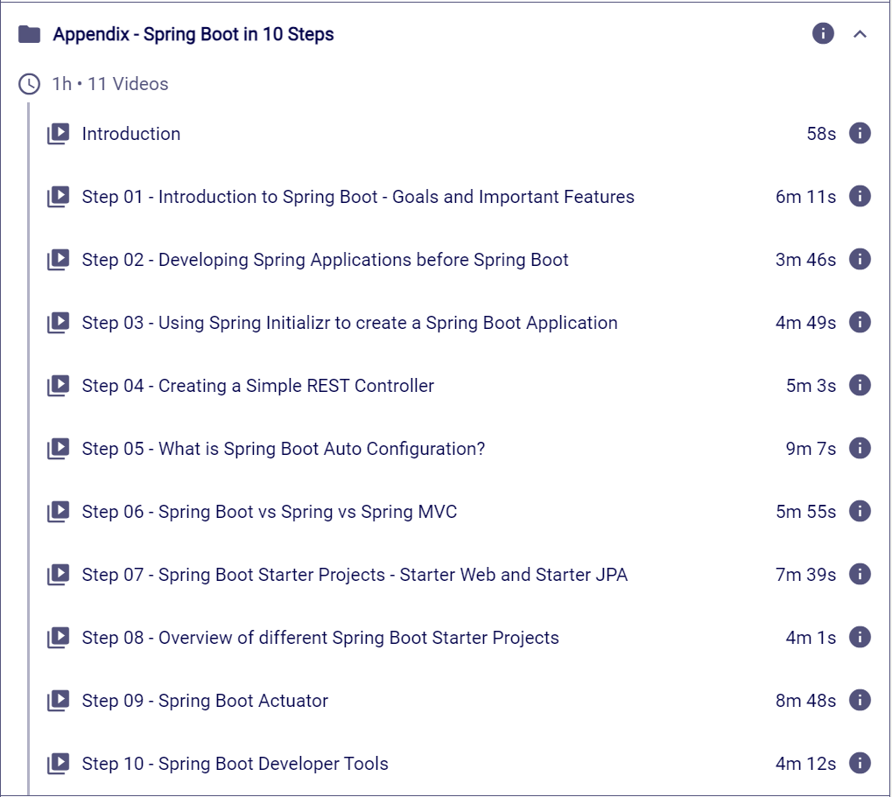

Fig 1.1 : Content of Appendix

1.11 First 10 Steps in JPA with H2 in-memory database

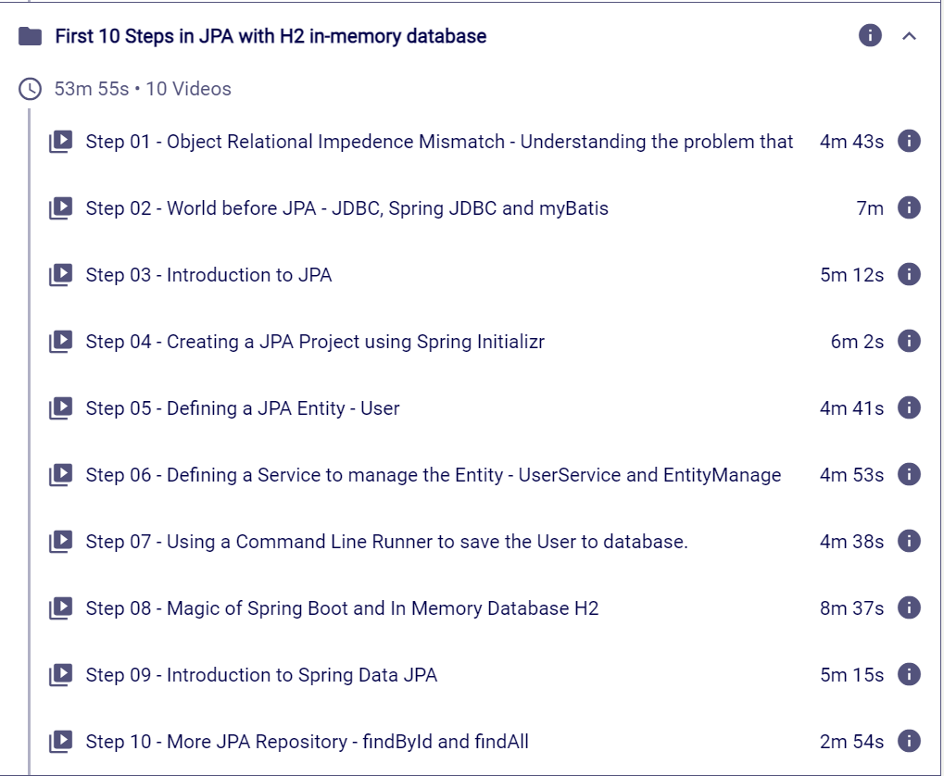

Fig 1.1 : Content of H2 in-memory DB

1.12 Assessment

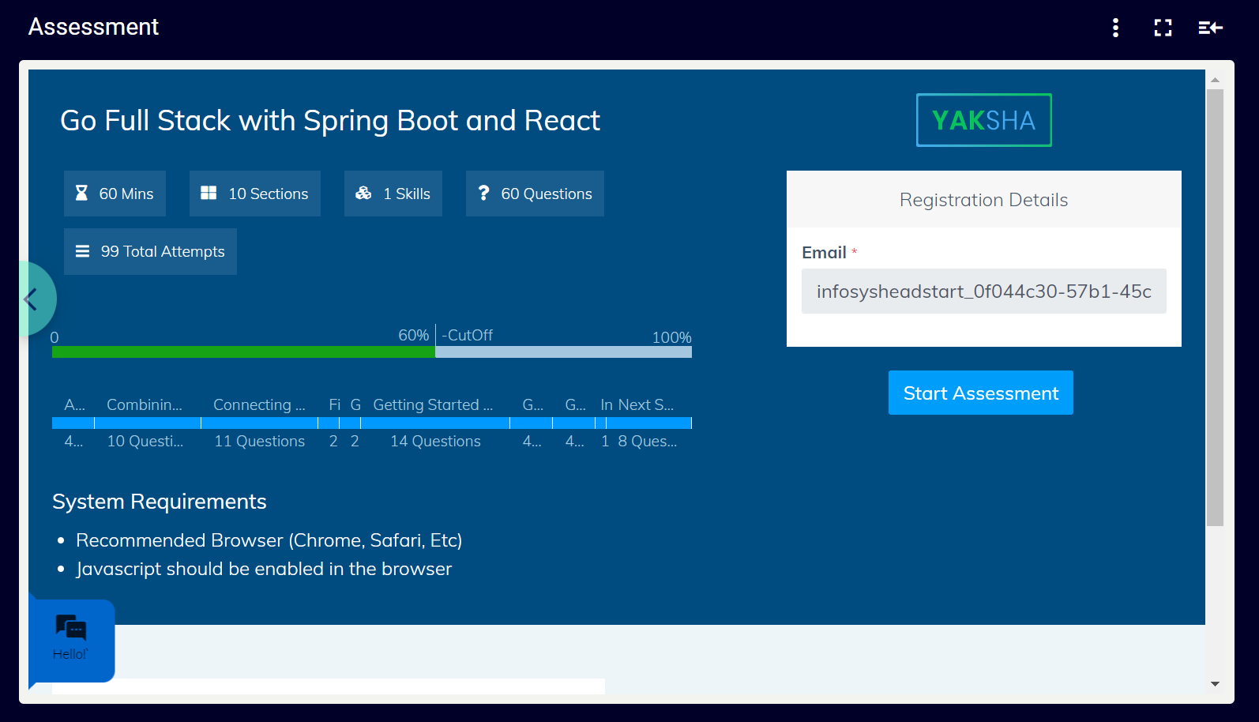

Fig 1.1 : Outline of Assessment

**Introduction:-**

This comprehensive course on going full stack with Spring Boot and React! In today's rapidly evolving tech landscape, the demand for versatile and skilled developers who can seamlessly navigate both the front-end and back-end aspects of web development is higher than ever. This course is designed to equip you with the essential skills and knowledge to become a proficient full-stack developer, leveraging the power of Spring Boot for back-end development and React for building dynamic and responsive user interfaces.

Throughout this course, you will embark on a journey that covers the entire spectrum of web development, from setting up a robust and scalable back-end with Spring Boot to crafting engaging and interactive front-end experiences using React. Whether you're a seasoned developer looking to expand your skill set or a newcomer eager to dive into the world of full-stack development, this course is tailored to meet your needs.

Our expertly crafted curriculum will guide you through the core concepts of Spring Boot and React, providing hands-on experience and practical insights that will empower you to build modern, feature-rich web applications. By the end of this course, you'll not only have a deep understanding of these powerful technologies but also the confidence to tackle real-world projects and contribute to the ever-growing field of full-stack development.

Get ready to elevate your development skills, unlock new opportunities, and embark on a rewarding journey into the world of full-stack web development with Spring Boot and React. Let's dive in and build something amazing together!

